Optical Illusions Art Gallery

Declaration

I declare that this assignment submission represents my own work (except for allowed material provided in the course), and that ideas or extracts from other sources are properly acknowledged in the report. I have not allowed anyone to copy my work with the intention of passing it off as their own work.

Name

Student ID

Date

# Description

The scene has 3 animated art objects (AAO), newtons cradle (AAO3), ames window (AAO1) and a rotating moire pattern (AAO2). The newtons cradle has physics simulation and displays 2 independent animation sequence with 1 and 2 balls dropped which cycles between them when the energy in the system gets low enough. The newtons cradle also has planar shadow system for all the balls. The scene has 2 static illusions which can be seen in the gallery view. The entire scene is surrounded by a quad strip with a repeated brick texture applied.

* Screenshots of AAOs and the gallery. You may also include screenshots or descriptions of any important/interesting aspect of the models, images and animations.

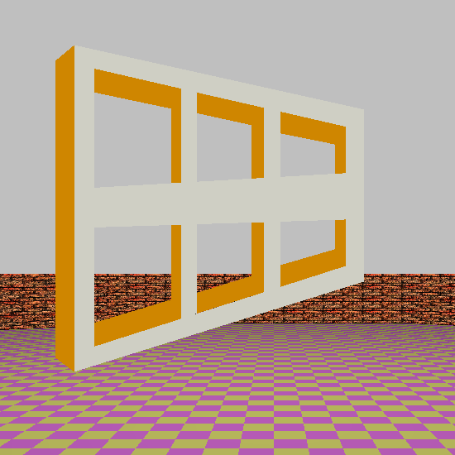 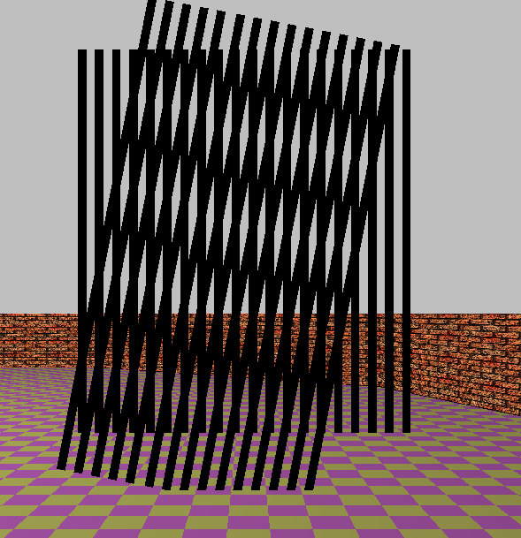

AAO 1: Ames window AAO 2 Rotating Moire pattern

AAO 3 Showing both animations (1 and 2 balls dropped). The planar shadows are simulated for each ball and the light source is in the middle above of the cradle slightly and in the positive z direction slightly. The 2 spotlights are on the end balls and are pointing to the ground.

# Extra features

* Planar shadows from the newtons cradle.
* 2 spotlights attached to the left and right ball in the newtons cradle.
* Physics based newtons cradle animation.
* Texture mapped quad strip (brick wall).
* 2 texture mapped quads (2 different illusions).

# Images of diagrams

# Equations

* Newtons cradle:
  + Update position of ball:
 $x=\left(balloffsetX+stringLength\right)*sin⁡(ballAngle)$

 $y=\left(balloffsetY+stringLength\right)*-cos⁡(ballAngle)$

  - * Balloffset is the initial starting position of the ball relative to the scene origin and ball angle is the angular displacement of the ball on the string in radians.
 $α=τ/I$     * Since the inertia of the ball is assumed to be 1 I is ignored
 $α=-(-stringLength*m*g*\cos\left(\left(ballAngle-45\right)\right)-stringLength*m*g*sin⁡(ballAngle-45))$     * Where m is the mass (1 for all balls and equations) g is -9.81.
 $ω_{f}=ω_{i}+α*dt$     * Where dt is change in time (set to 0.02)
 $ballAngle += ω*dt+\frac{1}{2}∙α∙{dt}^{2}$

 $Collisions:$

 $d=\sqrt{{(x_{2}-x_{1})}^{2}+{(y_{2}-y_{1})}^{2}}$

 - Distance between 2 points to check for a collision between the ball. To prevent clipping if the 2 balls are within 2 times the radius the and of the balls are moved away from each other until they are no longer clipping.
    - If a ball does collide the angular momentum of the balls are switched.

# Controls

|  |  |
| --- | --- |
| **Key** | **Action** |
| 1 | AAO-1 View |
| 2 | AAO-2 View |
| 3 | AAO-3 View |
| 0 | Gallery View |
| ← | Camera: Turn left |
| → | Camera: Turn right |
| ↑ | Camera: Move forward |
| ↓ | Camera: Move backward |
| Page up | Camera: Raise height |
| Page down | Camera: Lower height |

# Build Commands

# References

Equations for the AAO3: <https://www.nzqa.govt.nz/assets/qualifications-and-standards/qualifications/ncea/NCEA-subject-resources/Physics/L3-res-13-phys.pdf>

Static illusions:

Brick texture: lab4